Fundraising Guide

Hosting a fundraiser is a great way to educate others about Snyder-Robinson Syndrome and raise funds to support the Snyder-Robinson Foundation & our research initiatives. As a small nonprofit, our work is powered by our community of patients, families, friends and supporters. Grassroots fundraising is what makes it all possible. Fundraising is what keeps our organization running and funds research for SRS treatments. If you’re looking to make a difference, fundraising for SRF is a great way.

Ways to Fundraise

- Host an Event
Hosting your own fundraiser is a great way to spread awareness of SRS and provide family, friends, and neighbors with a fun opportunity to support the Snyder-Robinson Foundation.
If you are interested in hosting a fundraiser for SRF, contact us at Cameron.hancock@snyder-robinson.org so we can assist you in promoting it! We would love to feature your upcoming fundraiser on our social channels to help spread the word. You can also reach out to us and we’d be happy to help you organize your event.
Examples of a private fundraising event include:
Happy hours
Golf outings (or putt-putt for those with less golfing experience)
Silent Auctions
Game or Trivia Night
Luncheon
Hosting a 5k walk for SRS
Yard Sale or Virtual Yard Sales
Bake Sales
School Fundraiser
Direct Asks
Setting up a Personal Fundraising page (e.g. GoFundMe, Crowdwise)
Competing in an athletic competition such as a marathon or Obstacle Challenge and asking friends, family, and coworkers to pledge their support
Use your creativity! The sky is the limit when it comes to hosting fundraisers.

If you’re interested in hosting a fundraising event mentioned above, visit this page for more details on how to get started.

- Incorporating fundraising into major life events.
If you have a birthday, wedding, or some other milestone event in which you don’t have any interest in receiving presents, you can have your guests donate to SRF in lieu of gifts. This is a simple way to educate the people in your lives about SRS and contribute to our efforts for researching a cure for the disorder.

- Company Gift Matching
An easy and effective way to double your donation is through your employer. Many companies offer a charitable gift matching program, so contact your HR department to learn about what your company offers before donating! Many companies also allow employees to volunteer their time with local charities, and if that’s the case, we are always looking for volunteers!

- Social Media & Online Fundraising
Facebook makes it simple to raise funds – and they don’t charge any transaction fees, so 100% of the money raised supports the Snyder-Robinson Foundation. To learn how to set up a fundraiser on your Facebook page, follow these simple steps. Although the page in the link specifically mentions a birthday fundraiser, the same rules apply to any fundraiser you decide to host on Facebook, birthday or not!

Instagram also allows users to fundraise on behalf of an organization. You can do so either through Posts or Stories. If you decide to do it through posts, upload and edit your chose picture, then once you get to the page before posting that lets you tag and add details to your image, select “Add fundraiser” then search Snyder-Robinson Foundation.
You can also request donations through Instagram stories by clicking on the icon with the smiley face on the top of your story image, selecting “Donation” then searching for Snyder-Robinson Foundation.

Financial Guidelines:
The Snyder-Robinson Foundation is recognized by the Internal Revenue Service (IRS) as a tax-exempt charitable organization; this tax-exempt status is crucial for our ability to carry out our mission. In order to preserve this status, it is essential that you comply with the various IRS regulations regarding nonprofit fundraising activities. Below are some general guidelines:
- Because Snyder-Robinson Foundation is not hosting your event, it is considered a third-party event. For this reason, you will not be able to use the Foundation’s IRS 501(c)(3) charitable classification, federal tax ID number or tax-exempt certificate. However, if you provide name and address, or email address, for donors or sponsors, SRF will send them a personal thank you from the Foundation, which will serve as a receipt. Email Cameron.hancock@snyder-robinson.org with that information.
- The event organizer may not set up a temporary bank account in Snyder-Robinson Foundation’s name, as this is illegal.
- The event organizer may not keep any portion of the proceeds (beyond real expenses) as profit or compensation.
- Donors must be informed that the tax-deductible amount of a donation is only the amount that is over and above the value of any goods or services received in exchange for the donation. For example, if a participant pays $200 to participate in a golf outing, and the value of the outing is $50, the donation amount is $150. If a donor pays less than the value of an item, then they will not receive a tax deduction.
- If goods are sold to raise money as part of a fundraising event, it must be made clear to the event participants what percentage of the sale price benefits Snyder-Robinson Foundation.

DIY Fundraising Ideas

Silent Auction or Virtual Yard Sale
Ask your network if they have any valuable items, services, or experiences they would be willing to donate. Clean out your closet or basement for items to be auctioned. Use a website such as www.32auctions.com to host a silent auction.

Host a Happy Hour
Some restaurants dedicate certain happy hour slots to helping charities or nonprofits with raising money for their cause. Look in your area to see if there are any near you.

Golf Fundraiser or Putt-Putt Event
For the golf enthusiasts in your life, a good way to get your community together and raise money for SRS is through a golf event. Many golf courses partner with nonprofits for hosting these charitable events, so contact courses in your area to see what options are available.
Because golf events often involve a lot of logistics and many attendees, our advice is to keep the first one you host simple. Charge a certain amount per head to play, contact local vendors to see if there are any sponsorship opportunities available in your area, and finish the event with a simple bbq and beer station.

Game or Trivia Night
Host an in-person or virtual (via Zoom for example) game or trivia night where admission tickets go towards raising money for SRF. If you’re interested in hosting something like this virtually, there is a step-by-step guide you can find here: www.pcmag.com/how-to/host-a-virtual-game-night

Run/Walk/Bike
Your race participants complete the race whenever and wherever they like, choosing to run
on a treadmill, in their neighborhood, or up a mountain trail. Use an app like JustMove or a
site such as https://runsignup.com/ to host.

Example Fundraising Letter

Dear Friends and Family,

As many of you already know, our [son/daughter] [child’s name] was diagnosed with a genetic disorder called Snyder-Robinson Syndrome (SRS).

We are participating in the Snyder-Robinson Foundation’s [INSERT NAME] event to raise funds for research towards treatments and cures for the disorder.

-OR-
We are hosting a fundraiser to raise awareness and funds to go towards the Snyder-Robinson Foundation’s mission to find treatment and cures for the disorder.

SRS is extremely rare, with a little over 100 known cases world-wide. Although SRS is a spectrum, many SRS patients are non-verbal, unable to walk, and face major medical challenges daily. Many suffer severe and frequent seizures, bone fractures, respiratory issues, among other various conditions.

There’s no cure, yet. Fortunately, there is hope and my family is committed to improving the lives of those with SRS.

The incredible researchers who work hard at understanding SRS have hope that there are plausible treatments for the disorder. The best way to help them with their journey’s towards an SRS cure is to provide funding that will grant them the ability to continue on their paths.

Please help support the Snyder-Robinson Foundation and those affected by SRS by donating to my fundraising page and/or joining Team [INSERT YOUR TEAM NAME] and helping us to raise funds at [INSERT YOUR FUNDRAISING PAGE LINK HERE]. Thank you for your generosity and help. We truly appreciate it! Learn more about Snyder-Robinson Syndrome and follow our efforts at www.snyder-robinson.org.

[YOUR NAME]
Step-by-Step Guide to Hosting a Fundraiser through Auxilia

- Visit theauxilia.com
- Click Log In on the upper right corner
- If you have donated to SRF in the past, you will have an auxilia account by default. Login via email. If not, you can sign up just as easily.
- Once logged in, click on the Organizations tab on the top of the page.

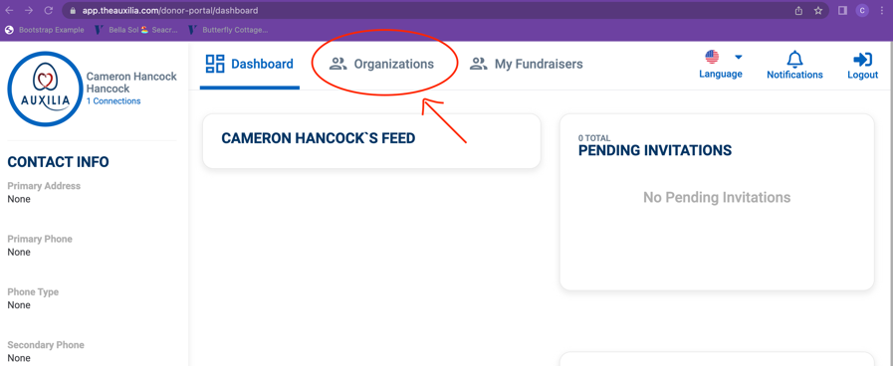

- Click on Filter by Name, Location, Cause, Mission, Zip

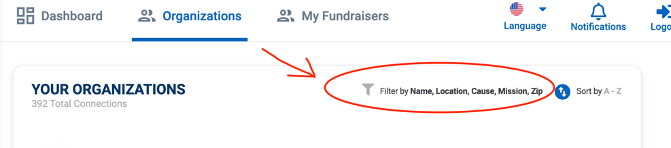

- Type in “The Snyder-Robinson Foundation” and search.

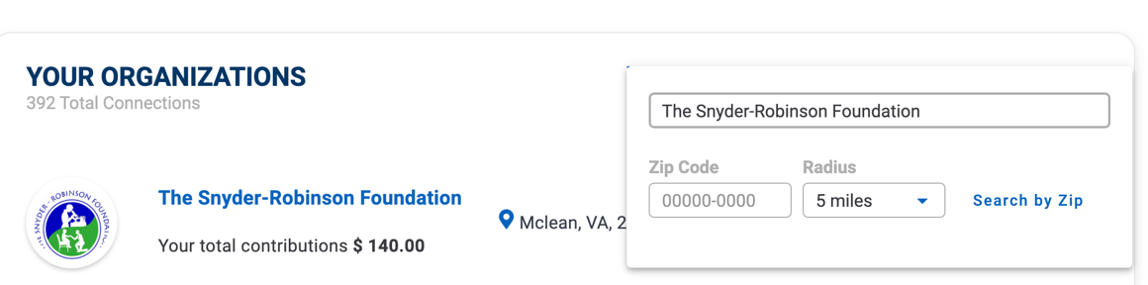

- Click on The Snyder-Robinson Foundation’s page, then click the “Support” button on the top right of the page.
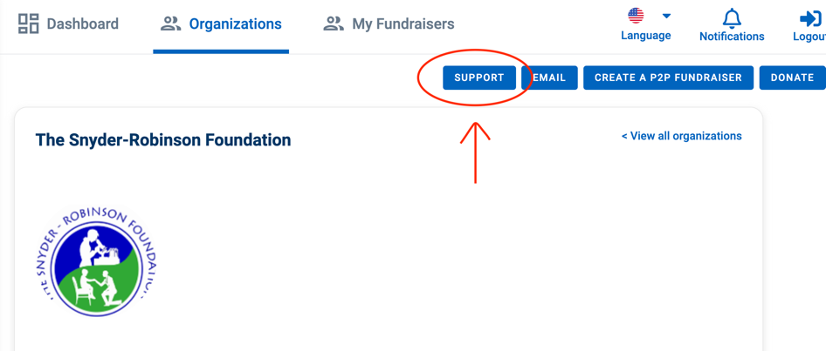

- To create a fundraiser, stay on the same page and click on the CREATE A P2P FUNDRAISER button located right by the support button.

12.

Tapping into your Network

Since SRS is such a rare disease, our patient and family community on its own only consists of a couple hundred people. A good way to extend our reach, educate more people about SRS, and create connections with potential funders and volunteers is by reaching out to our wider networks.

